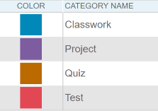
HOW TO ENTER WEIGHTED GRADES

Inactivate Unnecessary Categories

Open PowerTeacher Pro. Make sure your first class is at the top.

1. Click on Grading to the left, then Categories.

These categories need to be inactivated.

You can also make all of the 833 categories inactive if you do not teach any Act 833 students.

2. Click on the Edit pencil to the far right of each category. Change each one to Inactive. You will need to click on the

Assignment Default tab and choose anything for the Publish Assignment box then click on SAVE.

LPPS Categories have already been created, they have HS at the end of the name – do not change these.

If you must add categories, complete the following:
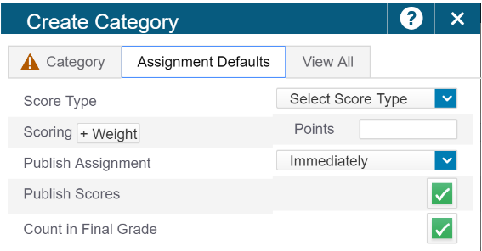

1. Click on the + Create at the top of page and choose Category.

2. On the Category tab, leave the Select Class box alone.

3. Type in the full name of the category – do not abbreviate, please.

4. Designate the color you want – I chose Purple because none of the other categories

were that color.

5. You can type a description if you want.

6. Click on the Assignment Defaults tab. Select Points as the Score Type.

7. You can enter the default points or leave it blank. Do not click on Weight.

8. Leave Publish Assignment as Immediately.

9. Leave Publish Scores checked

10 Unclick Count in Final Grade. Then click SAVE

Set up Weighted Categories.

1. On the left, click on Settings icon with the gear ( ), then click on Traditional Grade Calculations.

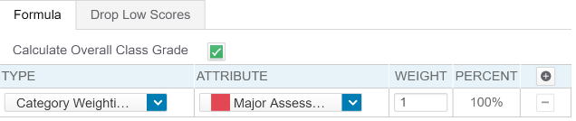
2. Start with your first class and with I1 (Interim 1) – Click the pencil at the right.

3. In the window, change the Type to “Category Weighting”.

One of the categories will appear. Click the + at the top right of the window

and change the Type to “Category Weighting” until all of the 4 main

categories appear. (You do not need to add Other)

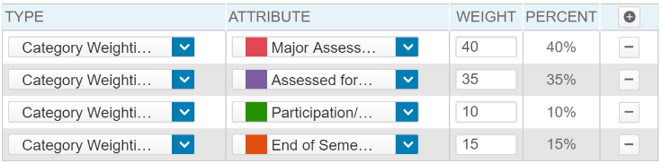
4. Once you have all the categories, enter the numbers in the Weight

boxes as shown in the diagram.

5. Click Save.

6. You will have to do this again for Interims (I2 & I3) and for S1.

7. You will need to this for all your classes in Semester 1.

8. AND you will need to do this again in Semester 2 for all Interims (I4, I5 & I6) and for all classes ---so you probably should do it now.

SORRY!

