Connect Your Computer with a Wireless Epson Projector

To Install the Program:
Click here
Step 1: Get into your Z drive:

Your file explorer should open and your Z drive is here:
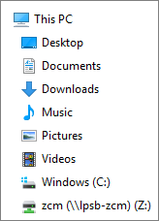

Step 2: Open the folder labeled “Projection Software”, then “Epson Projector”.
Step 3: Click “Epson Network Projection” and then “Run”
Once installed, it is called “EasyMP Network Projection Ver 2.86”

To Run the Program:
Step 1: Open the program (EasyMP Network Projection Ver 2.86)
Step 2: Select “Advanced Connection Mode” and it will open and start to search for your projector. It won’t find it.
Step 3: Turn on your projector, then hit the LAN button on your projector remote (remotes may vary).
Your screen should turn blue and have this (but with numbers following the IP address and Keyword and you may not have an SSID):
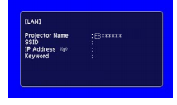
Step 4: Click “Manual Search” at the top of the program.
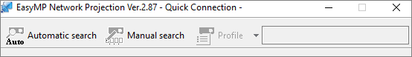

Step 5: Enter the IP address of the projector and hit “OK”
Step 6: Once projector is found, select the projector, then click “Connect”; it will ask for the keyword. Enter the Keyword from the projector screen.

Congratulations! You are now connected!

