For Chrome | For Internet Explorer | For Microsoft Edge
Click on the ellipses in the top right hand corner:  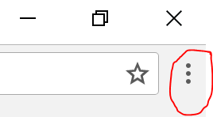  Click on “more tools” and then “clear browsing data”  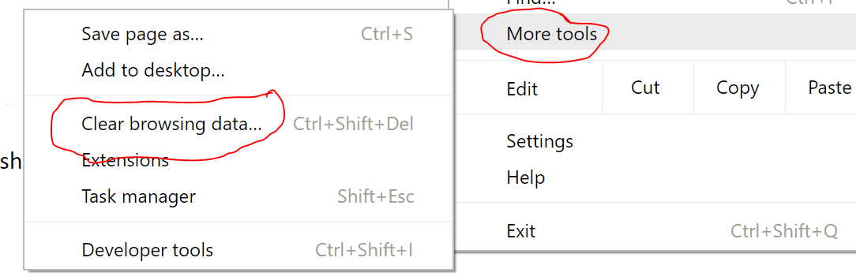  Make sure the option for deleting “passwords” is selected | Select the gear on the top right hand corner, then select “internet options”  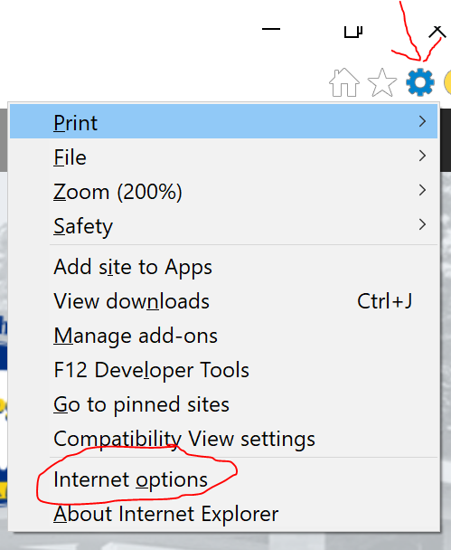  Then select “delete browsing history on exit” and then “delete”  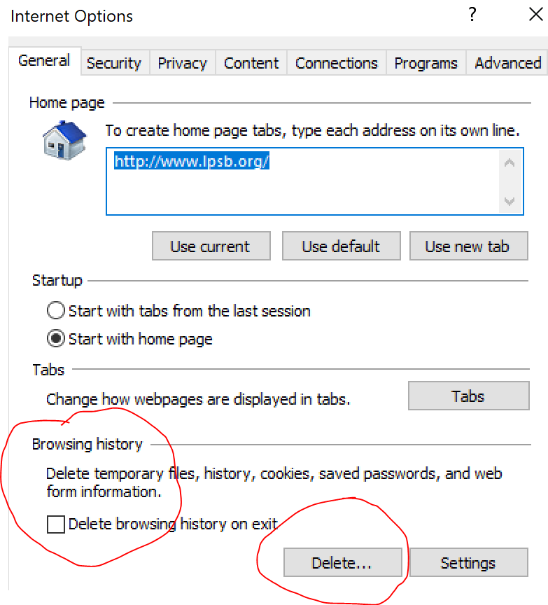 | Click on the ellipses in the top right hand corner:  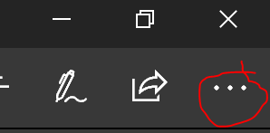  Click “Settings”, then scroll down and select “clear browsing data”  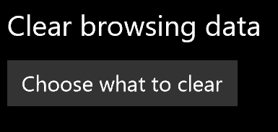
 |  | For Mozilla Firefox
Click on the 3 lines at the top right hand corner, then “Options”
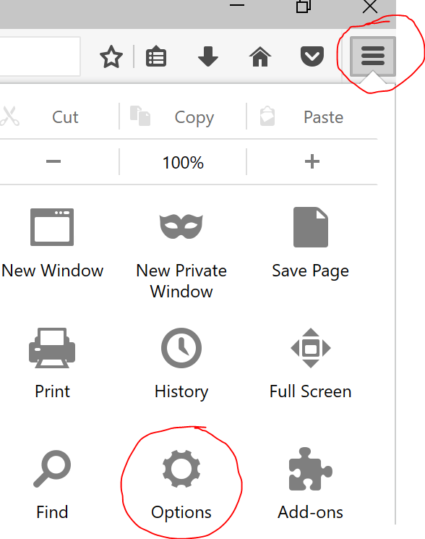
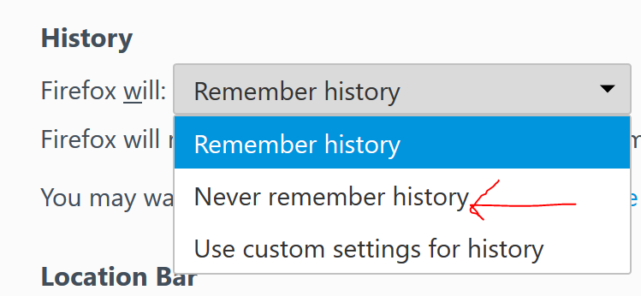
How to clear browser data and delete stored passwords:

